# Problem 4 – Teleport Points

The program is very basic. The device can **teleport** a person **to any point** within a **radius R**. It also has a **step H**, which is the **distance between two neighboring points**. H has to be set manually, so **it cannot change** in the middle of a calculation. The device can only be used **within rectangular rooms** and the teleport **cannot pass through walls**. Deadpool knows that you are a junior developer, so your algorithm must work only **within a two-dimensional space**.

You will be given the coordinates of the **four points of the rectangle**, which will represent **the room**. You will also be given the **value R**, which is the **radius** of the device and the **value H**, which is the device's **step**. Deadpool's position will **always be 0,0**. Your task is to count **all possible points** Deadpool can **teleport** **to**. Points that will make him teleport **within a wall**, are **not considered valid**.

You should probably start working now. Deadpool does not regard patience as a virtue. He did draw you a pretty picture however, so that you can get a better understanding of your task.

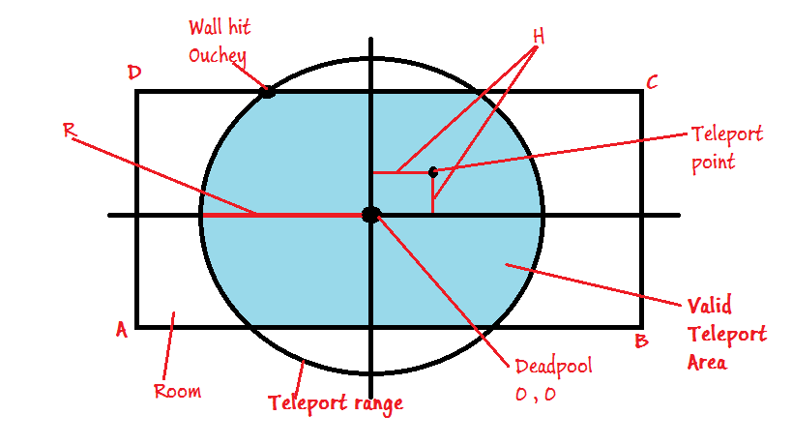

**Input**

The input should be read from the console and will consist of exactly 6 lines.

* The first **4 lines** will contain the **[X Y] coordinates** for each of the **four points** of the room.
* The **X** and the **Y** values will be separated by a **single space**.
* **Lines 5 and 6** will contain the values of the radius **R** and the step **H** respectfully.

1. **[X Y]** – coordinates for point A
2. **[X Y]** – coordinates for point B
3. **[X Y]** – coordinates for point C
4. **[X Y]** – coordinates for point D
5. **R** – Radius
6. **H** – Step

**Output**

* The output should consist of a single number, representing the count of valid teleport points.

**Constraints**

* **X and Y** will always be in the range [-30.5 … 30.5]
* **R and H** will always be in the range [0.1 … 30.5]
* **A, B, C, D** will always form a rectangle.
* Allowed working time for your program: 0.25 seconds.
* Allowed memory: 16MB.

**Examples**

|  |  |  |  |  |  |
| --- | --- | --- | --- | --- | --- |
| **Input** | **Output** | **Explanation** |  | **Input** | **Output** |
| -20 -3  20 -3  20 3  -20 3  10  0.4 | 731 | The room is **40** wide and **6** tall. The circle has radius of **10**. Total points within the area with step **0.4** are **731**. |  | -7.2 -8.8  10.4 -8.8  10.4 9.1  -7.2 9.1  30.5  1 | 324 |